Cynllun Lles Lleol Bwrdd Gwasanaethau Cyhoeddus Abertawe

Swansea Public Services Board Local Well-being Plan
Swansea Public Services Board is how organisations who work to improve well-being in Swansea come together to make a difference.
Every five years we write a plan to decide how we can work together to improve quality of life in Swansea both now and in the future
We need your help to identify things we could work together on to meet our draft well-being objectives

Bwrdd Gwasanaethau Cyhoeddus Abertawe yw'r ffordd y mae sefydliadau sy'n gweithio i wella lles yn Abertawe yn dod ynghyd i wneud gwahaniaeth.
Bob pum mlynedd rydym yn ysgrifennu cynllun i benderfynu sut gallwn weithio gyda'n gilydd i wella ansawdd bywyd yn Abertawe yn awr ac yn y dyfodol.
Mae angen eich help chi arnom i nodi pethau y gallem weithio gyda'n gilydd arnynt i fodloni'n hamcanion lles drafft.
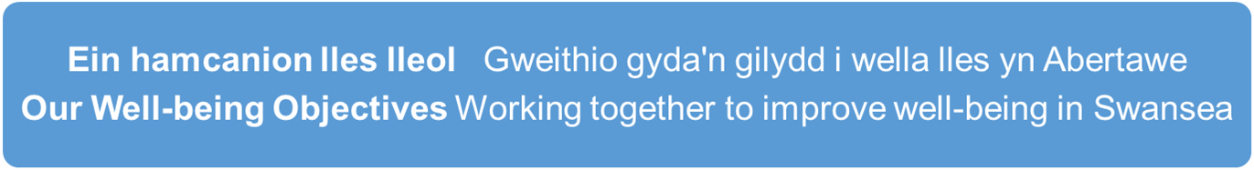
Early Years

Children have the best start in life to be the best they can be

Ein hamcanion lles lleol

Gweithio gyda'n gilydd i wella lles yn Abertawe

Live Well, Age Well

To make Swansea a great place to live well at every stage of life

Y Blynyddoedd Cynnar

Plant yn cael y dechrau gorau mewn bywyd i fod y gorau y gallant fod

Newid yn yr Hinsawdd ac Adferiad Natur
Adfer a gwella bioamrywiaeth, mynd i'r afael â'r achosion a lleihau effaith newid yn yr hinsawdd

Climate Change and Nature Recovery
To restore and enhance biodiversity, tackle the causes and reduce the impact of climate change

Strong Communities
To build cohesive communities
with a sense of pride and belonging
Cymunedau cryf

Adeiladu cymunedau cydlynol a chanddynt ymdeimlad o falchder a pherthyn

Rhannwch eich syniadau â ni yn www.abertawe.gov.uk/dweudeichdweud
Please share your ideas with us at www.swansea.gov.uk/haveyoursay
Dweud Eich Dweud Have Your Say

Dywedwch wrthym eich syniad am sut y gall gwasanaethau cyhoeddus weithio gyda'i gilydd i wella lles?

Please tell us your idea for how public services can work together to improve well-being?

1 Dywedwch wrthym beth yw teitl eich syniad (hyd at 15 gair)
1 Tell us the title of your idea (up to 15 words)
……………………………………………………………………………………………………………..
……………………………………………………………………………………………………………..

2 Yr her neu'r mater y mae'n mynd i'r afael ag ef
2 The challenge or issue it addresses
………………………………………………………………………………………………………………
………………………………………………………………………………………………………………
………………………………………………………………………………………………………………

3 Ac ychydig amdano
3 and a little about it

(if you know tell us about what this will mean in short medium and long term, any other governance, resource (existing or potential), buy in or leadership, the value the PSB can add and how it will be measured and the difference it will make to people’s lives)
(os ydych yn gwybod, dywedwch wrthym beth fydd hyn yn ei olygu yn y tymor byr, canolig a hir, ac unrhyw lywodraethu, adnoddau (presennol neu bosib), ymrwymiad neu arweinyddiaeth, y gwerth y gall y BGC ei ychwanegu a sut y caiff ei fesur a'r gwahaniaeth y bydd yn ei wneud i fywydau pobl)
……………………………………………………………………………………………………………….
……………………………………………………………………………………………………………….
……………………………………………………………………………………………………………….
……………………………………………………………………………………………………………………………………….…………………………………………………………………………………………..

Gallwch awgrymu cynifer o syniadau ag y dymunwch
Diolch.
llenwch yr arolwg llawn yn
www.abertawe.gov.uk/dweudeichdweud
22 Tachwedd 2022 i 13 Chwefror 2023

You can suggest as many ideas as you need
Thank you
complete the full survey at
www.swansea.gov.uk/haveyoursay
22 November 2022 to 13 February 2023

