THE COUNCIL OF THE CITY AND COUNTY OF SWANSEA
CYNGOR DINAS A SIR ABERTAWE
TEMPORARY ROAD CLOSURES & TRAFFIC PROHIBITIONS
HMS CAMBRIA FREEDOM PARADE
NOTICE 2025

The Council of the City and County of Swansea in exercise of the powers conferred by Section 21 of the Town Police Clauses Act 1847 HEREBY GIVE NOTICE that on Saturday 1st March 2025 and as when the appropriate traffic signs are displayed no person shall cause a vehicle (other than a vehicle being used for emergency purposes) to proceed along the length or lengths of road(s) referred to in the Schedule below.

SCHEDULE

Swansea Council Special Events Team will be co-ordinating the traffic management of the HMS Cambria Parade on Saturday 1st March 2025.

The Regiment will line up at the Guildhall Circle for inspection and the parade will step off at approximately 11.15am, it is anticipated the parade will finish at approximately 11.45am

In order to facilitate public safety for the regiment and the public, it will be necessary to close several roads and prohibit parking along the route as detailed in the schedule below. These road closures will only be in effect, and as required to facilitate the parade with approximate timings as follows:-

Road Closures – 06:00 – 11:30

Guildhall Circle
Guildhall Road North

No Parking and Tow Away Order - 07:00 – 12:30

St Helens Crescent
St Helens Road
Oxford Street
Princess Way

Rolling Road Closures - 10.30 – 12:30

St Helens Crescent
Guildhall Road South
St Helens Road
Kingsway Roundabout
Dillwyn Street
Oxford Street
Whitewalls
St Mary’s Square
Princess Way
A4067 Oystermouth Road

Access for pedestrians and emergency vehicles to be maintained at all times.

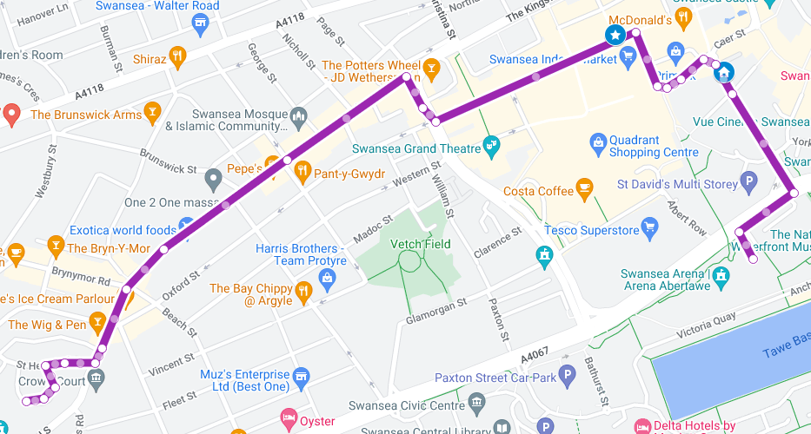

Dated this 19th February 2025
DEBRA JAYNE SMITH
CHIEF LEGAL OFFICER / PRIF SWYDDOG CYFREITHIOL
BUSNES
LEGAL & DEMOCRATIC SERVICES
GWASANAETHAU CYFREITHIOL A DEMOCRATAIDD
CIVIC CENTRE
CANOLFAN DDINESIG
SWANSEA
ABERTAWE
SA1 3SN
If you have any queries about this Notice please ring Dean Howard on 01792 841675



(ref DVT- 00279748)

