THE COUNCIL OF THE CITY AND COUNTY OF SWANSEA
CYNGOR DINAS A SIR ABERTAWE
TEMPORARY (ROLLING) ROAD CLOSURES
ARMED FORCES DAY PARADE
NOTICE 2025

The Council of the City and County of Swansea in exercise of the powers conferred by Section 21 of the Town Police Clauses Act 1847 HEREBY GIVE NOTICE that on Saturday 28th June 2025 between 11:00hrs and 12:00hrs and as when the appropriate traffic signs are displayed no person shall cause a vehicle (other than a vehicle being used for emergency purposes) to proceed along the length or lengths of road(s) referred to in the Schedule below.

SCHEDULE

The Armed Forces are organising a Parade on Saturday 28th June 2025 between 11:00hrs and 12:00hrs for which rolling road closures will be required.

The (rolling) road closures will last for the duration the parade takes to march along the designated route as follows:-

- Oxford Street (from its junction with Little Gam St to Whitewalls)
- Whitewalls (Whole length)
- St Marys Square (Whole length)

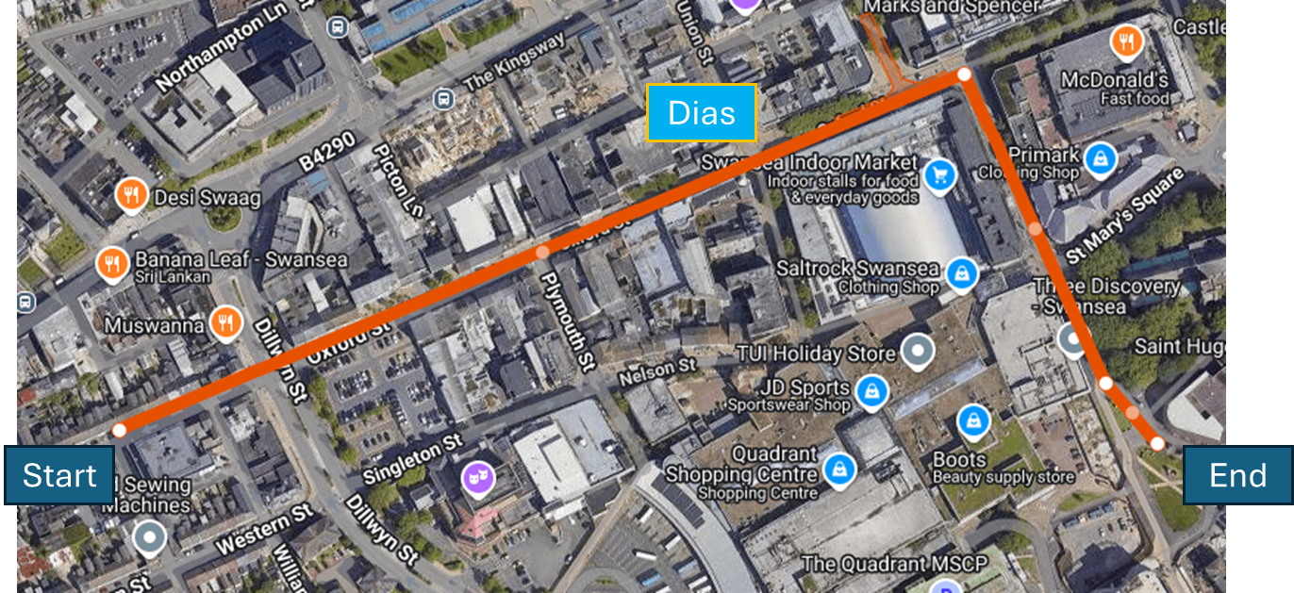

Should you have any queries or require further information, please contact Dean Howard on 01792 841675.

Dated this 25th June 2025
L A MOORE
CHIEF LEGAL OFFICER / PRIF SWYDDOG CYFREITHIOL
LEGAL & DEMOCRATIC SERVICES
GWASANAETHAU CYFREITHIOL A DEMOCRATAIDD
CIVIC CENTRE
CANOLFAN DDINESIG
SWANSEA
ABERTAWE
SA1 3SN

(ref DVT-00275365)

