THE COUNCIL OF THE CITY AND COUNTY OF SWANSEA
CYNGOR DINAS A SIR ABERTAWE
PROPOSED TRAFFIC REGULATION ORDER
GWYDR SQUARE, UPLANDS
CONVERSION OF CARRIAGEWAY TO FOOTWAY
NOTICE 2025

NOTICE is hereby given that the Council of the City and County of Swansea intends to make an Order in pursuance of its powers as contained in the Road Traffic Regulation Act 1984 (as amended) (“the Act”) the effect of which is as set out in the Schedule(s) below. A copy of the proposed Order, Statement of Reasons and an appropriate plan may be inspected during normal office hours at the Civic Centre Oystermouth Road Swansea SA1 3SN. Any objections to the proposals should be submitted in writing setting out the reasons thereto to reach the undersigned at the above address or via E-mail at Legal.TrafficNotices@swansea.gov.uk by the 28th October 2025 quoting reference DVT- 284539/EE.

SCHEDULE 1

REVOCATIONS

The existing Orders are revoked insofar as they are inconsistent with the proposals hereinafter contained which relate to the length or lengths of the road or roads referred to in the schedules hereto.

SCHEDULE 2

Designation of carriageway to become footway

GWYDR SQUARE

East Side

In accordance with Section 75(1) of The Highways Act 1980 the area shown in red on the “Drawing No T.23MISC.07_002” is to be designated as a “footway”.
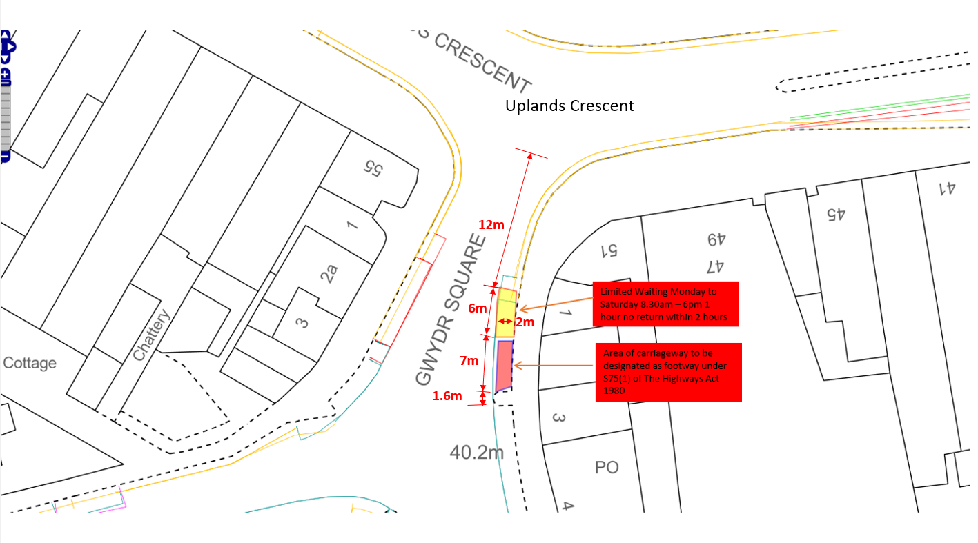
For clairty: Gwydr Square - On its eastern side from a point 18 metres south of its junction with Uplands Crescent southwards for a distance of 7 metres
SCHEDULE 3
Limited Waiting 1 hour no return within 2 hours Mon – Sat 8.30am – 6.00pm
Gwydr Square
On its eastern side from a point 12 metres south of its junction with Uplands Crescent southwards for a distance of 6 metres
SCHEDULE 3
Prohibition of Waiting, No Loading/ Unloading At Any Time
Gwydr Square
On its eastern side from a point 18 metres south of its junction with Uplands Crescent southwards for a distance of 7 metres


7th October 2025
L A Moore
Chief Legal Officer / Prif Swyddog Cyfreithiol

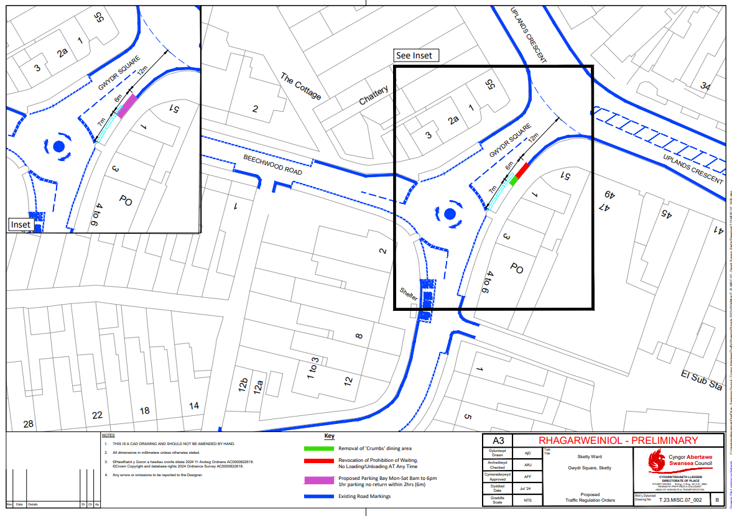

STATEMENT OF REASONS

Notice of Intent for the Traffic Regulation Order

GWYDR SQUARE, UPLANDS
CONVERSION OF CARRIAGEWAY TO FOOTWAY

The conversion/ designation of carriageway into footway is to allow a licence to be granted for the tables and chairs currently situated on the carriageway in the area indicated on the plan below.

The amendment to the limited waiting bay is to revoke the parking bay which the tables and chairs sit on and which will become designated footway.

- For preserving or improving the amenities of the area through which the road runs.

Extract from RTRA 1984

2 What a traffic regulation order may provide.
(1) A traffic regulation order may make any provision prohibiting, restricting or regulating the use of a road, or of any part of the width of a road, by vehicular traffic, or by vehicular traffic of any class specified in the order,—
(a) either generally or subject to such exceptions as may be specified in the order or determined in a manner provided for by it, and
(b) subject to such exceptions as may be so specified or determined, either at all times or at times, on days or during periods so specified.

THE COUNCIL OF THE CITY

AND COUNTY OF SWANSEA

CYNGOR DINAS A SIR ABERTAWE



DRAFT

TRAFFIC REGULATION ORDER
VARIOUS LOCATIONS
GWYDR SQUARE, UPLANDS
CONVERSION OF CARRIAGEWAY TO FOOTWAY
ORDER 2025

DVT-284539/EE

THE COUNCIL OF THE CITY
AND COUNTY OF SWANSEA
CYNGOR DINAS A SIR ABERTAWE

TRAFFIC REGULATION ORDER

GWYDR SQUARE, UPLANDS

CONVERSION OF CARRIAGEWAY TO FOOTWAY

ORDER 2025

THE COUNCIL OF THE CITY AND COUNTY OF SWANSEA (hereinafter called “the Council”) in exercise of its powers under the Road Traffic Regulation Act 1984, as amended (hereinafter referred to as “the 1984 Act”), the Traffic Management Act 2004(“the 2004 Act”), the Local Government (Miscellaneous Provisions) Act 1976 (“the 1976 Act”) and all other enabling powers, and after consultation with the Chief Officer of Police in accordance with Part III of Schedule 9 and Section 124 of the 1984 Act hereby makes the following Order.
DRAFT
SECTION 1 – PRELIMINARY
Citation and commencement

- This Order shall come into operation on XX XXXXXX 2025 and may be cited as the Council of the City and County of Swansea, Gwydr Square, Uplands (Conversion of Carriageway to Footway), Swansea Order 2025

Definitions

- In this order, except where the context otherwise requires, the following
expressions have the meaning hereby respectively assigned to them:

“Civil Enforcement Officer” has the same meaning as in Section 63A of the 1984 Act and by virtue of Section 76 of the 2004 Act a Civil Enforcement Officer appointed under Section 63A of the 1984 Act is a Civil Enforcement Officer in relation to parking contraventions;

“Disabled Person’s Vehicle” has the same meaning as in the Local Authorities’ Traffic Orders (Exemption for Disabled Persons) (Wales) Regulations 2000;

“Disabled Person’s Badge” has the same meaning as in the Disabled Persons (Badges for Motor Vehicles)(Wales) Regulation 2000;

“Parking Disc” means a disc and time clock (where appropriate) issued by a local authority complying with the requirements of the British Standard Specifications for Parking Discs to comply with the European Blue Badge Scheme being a disc coloured blue and capable of showing the quarter hour period during which a period of waiting begins;

“Relevant Position” in respect of:-

- a Disabled Person’s Badge and parking disc has the same meaning as in the Local Authorities’ Traffic Orders (Exemptions for Disabled Persons) (Wales) Regulations 2000; and

- a Waiver means exhibited on the windscreen, dashboard or fascia of the vehicle or, where the vehicle does not have a windscreen, dashboard or fascia, in a conspicuous position on the vehicle so that the whole of the information on the front of the waiver is clearly legible from outside the vehicle;
DRAFT
“Waiver” means a Waiver issued by the Council in respect of vehicles being used for building maintenance repair shop fitting or other industrial or demolition operations and the Council may charge for such waiver such charge to be determined from time to time by resolution of the Council or relevant Committee thereof;

Interpretation

- Except where otherwise stated, any reference in this Order to a numbered Article or Schedule is a reference to the Article or Schedule bearing that number in this Order

- The Interpretation Act 1978 shall apply for the interpretation of this Order as it applies for the Interpretation of an Act of Parliament

- The prohibitions and restrictions imposed by this Order shall be in addition to and not in derogation of any other prohibition or restriction whether made under the 1984 Act or otherwise

SECTION 2 - DESIGNATION OF CARRIAGEWAY TO BECOME FOOTWAY

No person shall, except upon the direction or with the permission of a Civil Enforcement Officer, police officer in uniform, or a person authorised by the Council, cause or permit any vehicle to proceed along any of the length or lengths of the road or roads described in Schedule 2 hereto and shown coloured red on the plan contained therein.

SECTION 3 - LIMITED WAITING 1 HOUR NO RETURN WITHIN 2 HOURS MON – SAT 8.30AM – 6PM

- Save as provided in Articles 8, 9 and 10 no person shall, except upon the direction or with the permission of a Civil Enforcement Officer, police officer in uniform, or a person authorised by the Council, cause or permit any vehicle to stop for a period in excess of 1 hour (unless separated by an interval of 2 hours) Monday to Saturday inclusive between the hours of 8 a.m. and 6 p.m. on any of the length or lengths of the road or roads referred to in Schedule 3 hereto.
Exemptions
- Nothing in Article 7 of this Order shall render it unlawful to cause or permit a vehicle displaying a physical permit in the Relevant Position or subject to a digital permit covering the specified area to stop on the side or sides or length or lengths of the road or roads specified in Schedule 3.
- Nothing in Article 7 of this Order shall render it unlawful to cause or permit any vehicle to stop on the side or sides or length or lengths of the road or roads specified therein for as long as may be necessary to enable:-
DRAFT
        - the vehicle, if it cannot conveniently be used for such purpose in any other road, to be used in connection with any of the following operations namely:-
          - building, maintenance, repair, shop fitting or other industrial or demolition operations with a Waiver issued by the Council and displayed in the Relevant Position on the windscreen of the vehicle;
          - the removal of any obstruction to traffic;
          - the laying, erection, alteration or repair in or on land adjacent to the said lengths or sides of the road of any sewer or any main pipe or apparatus for the supply of water, gas electricity or of any telecommunications apparatus as defined by the Telecommunications Act 1984; or
          - a vehicle being used for police, ambulance, fire brigade or other emergency purposes;
        - the vehicle if it cannot conveniently be used for such purpose in any other road, to be used in connection with the service of a local authority or of a water authority in pursuance of its statutory powers and duties;
        - the vehicle of the Royal Mail or other universal services provider as defined in Section 27 of the Postal Services Act 2011 to be used for the purpose of delivering or collecting mail; or
        - vehicles picking up and dropping off passengers.
- Nothing in Article 7 of this Order shall render it unlawful to cause or permit a disabled person’s vehicle which displays in the Relevant Position a Disabled Persons Badge and a Parking Disc (on which the driver, or other person in charge of the vehicle, has marked the time at which the period of waiting began) to wait on the length and sides of roads referred to in the Article for a period not exceeding 3 hours (not being a period separated by an interval of less than 1 hour from the previous period of waiting by the same vehicle on the same length of side of road on which that vehicle had previously been waiting.
DRAFT
SECTION 4 - PROHIBITION OF WAITING, NO LOADING/ UNLOADING AT ANY TIME
- Save as provided in Articles 12 and 13 no person shall, except upon the direction or with the permission of a Civil Enforcement Officer, police officer in uniform, or a person authorised by the Council, cause or permit any vehicle to wait load or unload at any time on the length or lengths of the road or roads referred to in Schedule 4 hereto.
Exemptions

- Nothing in Article 11 of this Order shall render it unlawful to cause or permit any vehicle to wait on the side or sides or length or lengths of the road or roads specified therein for as long as may be necessary to enable:-

- the vehicle, if it cannot conveniently be used for such purpose in any other road, to be used in connection with any of the following operations namely:-

- building, maintenance, repair, shop fitting or other industrial or demolition operations with a Waiver issued by the Council and displayed in the Relevant Position on the windscreen of the vehicle;

- the removal of any obstruction to traffic;

- the laying, erection, alteration or repair in or on land adjacent to the said lengths or sides of the road of any sewer or any main pipe or apparatus for the supply of water, gas electricity or of any telecommunications apparatus as defined by the Telecommunications Act 1984; or

- a vehicle being used for police, ambulance, fire brigade or other emergency purposes;

- the vehicle if it cannot conveniently be used for such purpose in any other road, to be used in connection with the service of a local authority or of a water authority in pursuance of its statutory powers and duties;

- the vehicle of the Royal Mail or other universal services provider as defined in Section 27 of the Postal Services Act 2011 to be used for the purpose of delivering or collecting mail; or
DRAFT
- vehicles picking up and dropping off passengers.

- Nothing in Article 11 of this Order shall render it unlawful to cause or permit a Disabled Person’s Vehicle which displays in the Relevant Position a Disabled Persons Badge and a Parking Disc (on which the driver, or other person in charge of the vehicle, has marked the time at which the period of waiting began) to wait on lengths of sides of roads referred to in the Article for a period not exceeding 3 hours (not being a period separated by an interval of less than 1 hour from the previous period of waiting by the same vehicle on the same length of side of road on which that vehicle had previously been waiting.

REVOCATION
- The existing Orders are revoked insofar as they are inconsistent with the proposals contained in the schedules hereto and insofar as they relate to the length or lengths of the road or roads referred to in the Schedule hereto.

SCHEDULES

SCHEDULE 1

REVOCATIONS

The existing Orders are revoked insofar as they are inconsistent with the proposals hereinafter contained which relate to the length or lengths of the road or roads referred to in the schedules hereto.

SCHEDULE 2

Designation of carriageway to become footway
DRAFT

GWYDR SQUARE

East Side

In accordance with Section 75(1) of The Highways Act 1980 the area shown in red on the plan below is to be designated as “footway”.
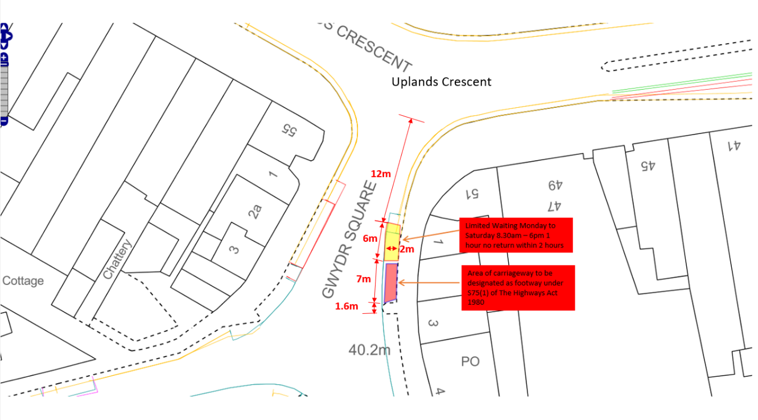
For clairty: Gwydr Square - On its eastern side from a point 18 metres south of its junction with Uplands Crescent southwards for a distance of 7 metres

SCHEDULE 3
Limited Waiting 1 hour no return within 2 hours Mon – Sat 8.30am – 6pm
Gwydr Square
On its eastern side from a point 12 metres south of its junction with Uplands Crescent southwards for a distance of 6 metres
SCHEDULE 3
Prohibition of Waiting, No Loading/ Unloading At Any Time
Gwydr Square
DRAFT
On its eastern side from a point 18 metres south of its junction with Uplands Crescent southwards for a distance of 7 metres

Dated this

THE COMMON SEAL OF THE )
COUNCIL OF THE CITY AND )
COUNTY OF SWANSEA )
was hereunto affixed )
in the presence of )

Authorised Signatory

