THE COUNCIL OF THE CITY AND COUNTY OF SWANSEA
CYNGOR DINAS A SIR ABERTAWE
PROPOSED TRAFFIC REGULATION ORDER
VARIOUS ROADS – BON-Y-MAEN WARD
VARIOUS RESTRICTIONS
NOTICE 2025

NOTICE is hereby given that the Council of the City and County of Swansea intends to make an Order in pursuance of its powers as contained in the Road Traffic Regulation Act 1984 (as amended) (“the Act”) and the Highways (Road Humps) Regulations 1999 (“the Regulation”) and Section 90A of the Highways Act 1980 (“the Act”) the effect of which is as set out in the Schedule(s) below. A copy of the proposed Order, Statement of Reasons and an appropriate plan may be inspected during normal office hours at the Civic Centre Oystermouth Road Swansea SA1 3SN or viewed online at https://www.swansea.gov.uk/permanenttro. Any objections to the proposals should be submitted in writing setting out the reasons thereto to reach the undersigned at the above address or via E-mail at Legal.TrafficNotices@swansea.gov.uk by the 24th November 2025 quoting reference DVT- 284665/EE.

SCHEDULES

SCHEDULE 1

REVOCATIONS

The existing Orders are revoked insofar as they are inconsistent with the proposals hereinafter contained which relate to the length or lengths of the road or roads referred to in the schedules hereto.

SCHEDULE 2

No Waiting At Any Time

BON-Y-MAEN ROAD
On its northern side from its junction with the western kerbline of Talfan Road westwards for a distance of 22 metres.

TALFAN ROAD
On its western side from its junction with the northern kerbline of Bon-y-Maen Road northwards for a distance of 4 metres.

BRANDON CRESCENT
On its eastern side from a point 62 metres south of its junction with the southern kerbline of Carmel Road southwards for a distance of 6 metres.

COLWYN AVENUE
On its northern eastern side from its junction with access into Cwm Glas Primary School north eastwards for a distance of 14 metres.

MANSEL ROAD
On its western side from a point 45 metres south of its junction with the southern kerbline of Cwm Chapel Road southwards for a distance of 50 metres.

CEFN HENGOED ROAD

Western Kerbline
On its western side from a point 93 metres north from its junction with the northern kerb line of Cefn Road in a northerly direction to the southern boundary of property number 126 Cefn Hengoed Road a distance of approximately 463 metres.

Eastern Kerbline
On its eastern side from a point 80 metres north from its junction with the northern kerb line of Cefn Road in a northerly direction for a distance of 197m, and from a point 320m north from its junction with the northern kerbline of Cefn Road in a northerly direction for a distance of 278m to a point opposite the common boundary of properties number 118/120 Cefn Hengoed Road, but excluding the lay-by covering a distance of 43 metres.

SCHEDULE 3

Revocation of No Waiting at anytime

CRYMLYN ROAD
On its northern kerbside from a point 22 metres east of its junction with the eastern kerbline of Carmel Road eastwards for a distance of 33 metres.

SCHEDULE 4

Installation of round topped speed hump

BON-Y-MAEN ROAD
On its southern side within the short service road fronting properties numbered 186 to 180 Bon-y-Maen Road.


3rd November 2025
L A Moore
Chief Legal Officer / Prif Swyddog Cyfreithiol

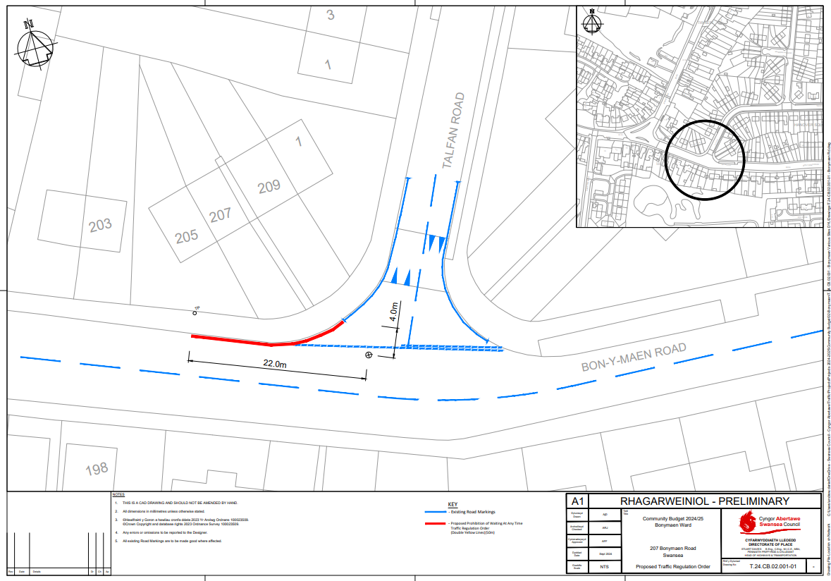
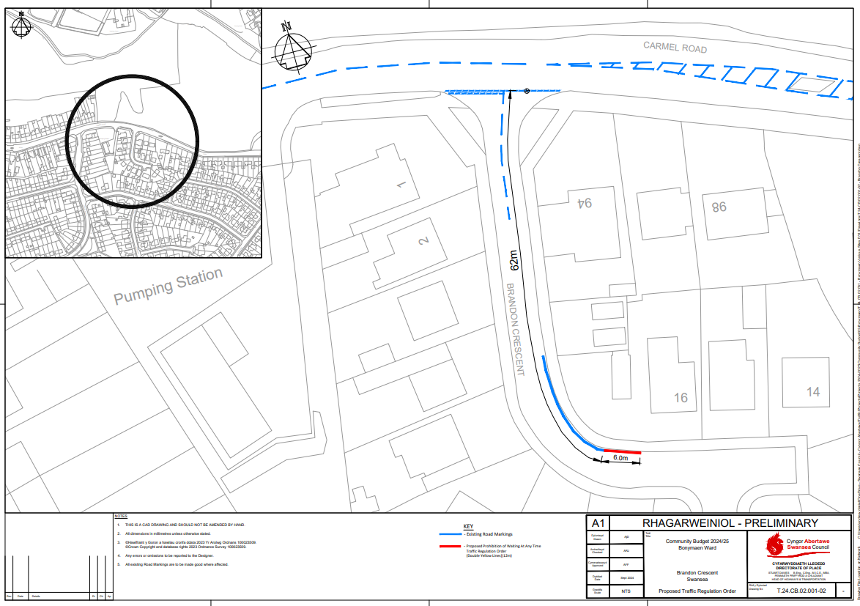
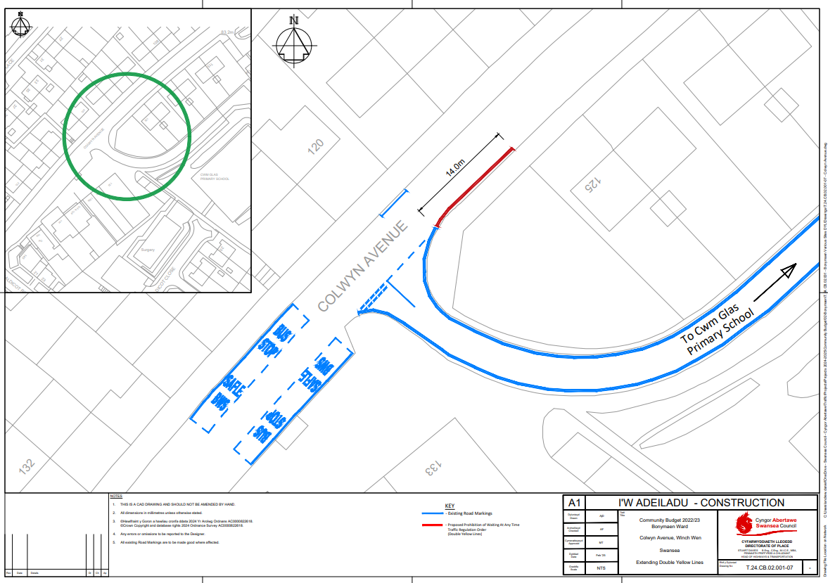
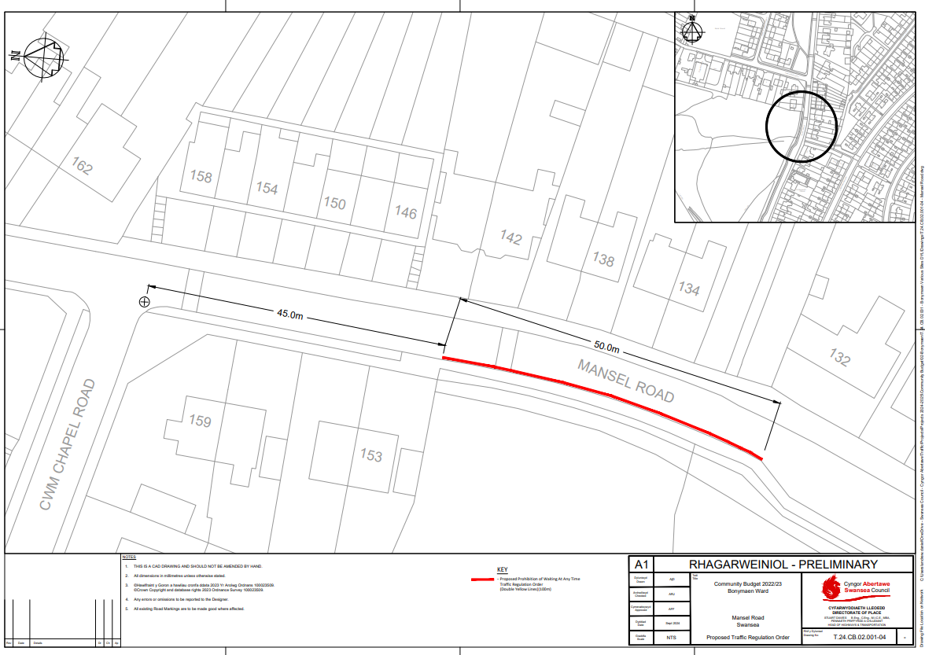
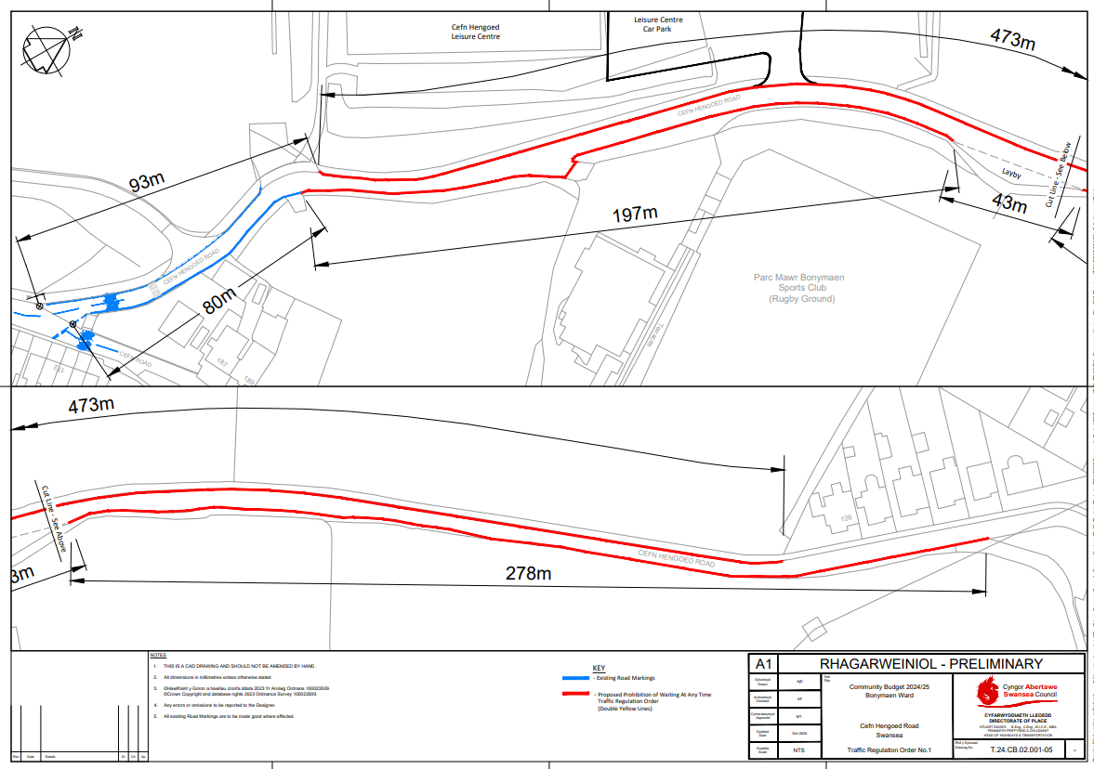
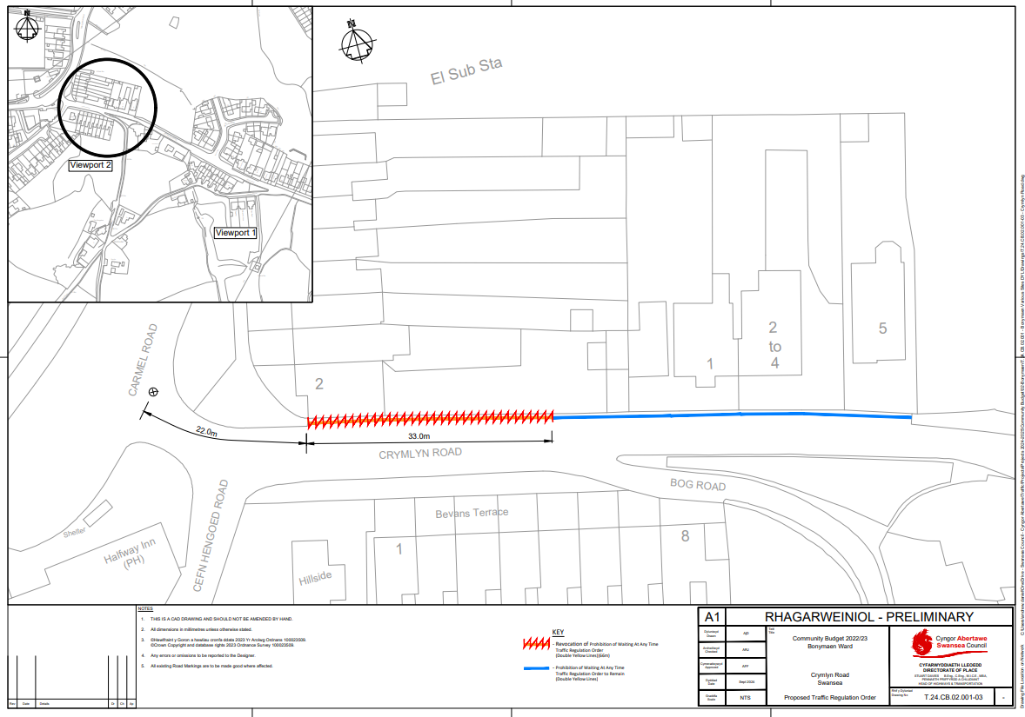
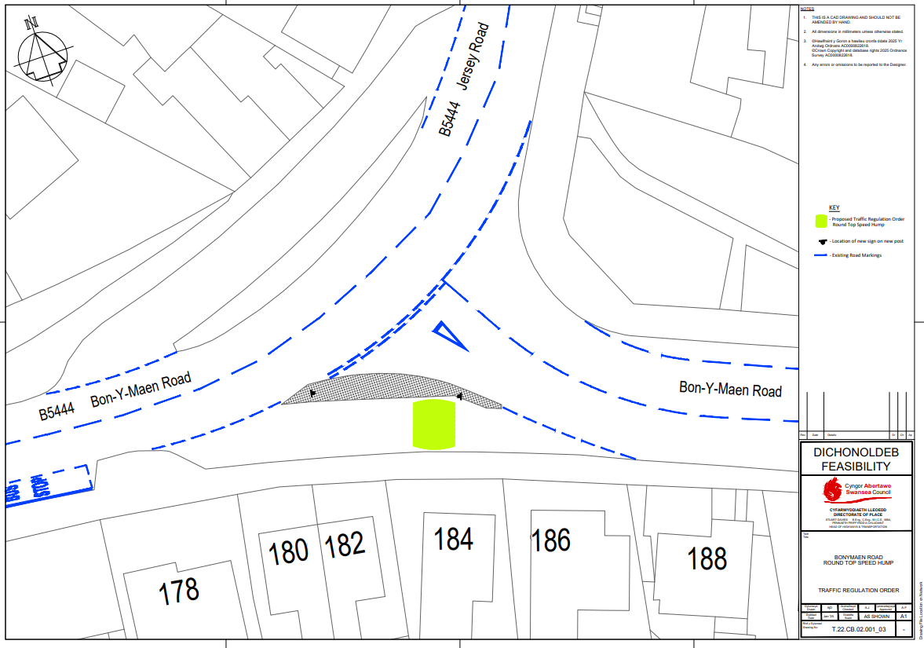
STATEMENT OF REASONS

Notice of Intent for the Traffic Regulation Order

VARIOUS ROADS – BON-Y-MAEN WARD

The waiting restriction proposed for these schemes are intended for the purpose of road safety in the vicinity of road junctions.

The removal of yellow lines at one location is to allow additional parking for residents.

The installation of a speed hump at one location is to prevent short cutting along a residential service road.

Extract from Road Traffic Regulation Act 1984

2 What a traffic regulation order may provide.
(1)A traffic regulation order may make any provision prohibiting, restricting or regulating the use of a road, or of any part of the width of a road, by vehicular traffic, or by vehicular traffic of any class specified in the order,—
(a) either generally or subject to such exceptions as may be specified in the order or determined in a manner provided for by it, and
(b) subject to such exceptions as may be so specified or determined, either at all times or at times, on days or during periods so specified.

THE COUNCIL OF THE CITY

AND COUNTY OF SWANSEA

CYNGOR DINAS A SIR ABERTAWE



TRAFFIC REGULATION ORDER
VARIOUS RESTRICTIONS
VARIOUS ROADS – BON-Y-MAEN WARD
ORDER 2025

DVT-284665/EE

THE COUNCIL OF THE CITY
AND COUNTY OF SWANSEA
CYNGOR DINAS A SIR ABERTAWE
TRAFFIC REGULATION ORDER
VARIOUS RESTRICTIONS
VARIOUS ROADS – BON-Y-MAEN WARD

ORDER 2025

THE COUNCIL OF THE CITY AND COUNTY OF SWANSEA (hereinafter called “the Council”) in exercise of its powers under Sections the Road Traffic Regulation Act 1984, as amended (hereinafter referred to as “the Act of 1984”) and the Traffic Management Act 2004 and the Local Government (Miscellaneous Provisions) Act 1976 and of all other enabling powers and after consultation with the Chief Officer of Police in accordance with Part III of Schedule 9 and Section 124 of the Act of 1984 hereby make the following Order.

SECTION 1 – PRELIMINARY
Citation and commencement

- This Order shall come into operation on XX XXXXXX 202X and may be cited as the Council of the City and County of Swansea, Traffic Regulation Order, (Various Restrictions), Various Roads, Bon-y-Maen Ward, Swansea Order 2025
Definitions

- In this order, except where the context otherwise requires, the following
expressions have the meaning hereby respectively assigned to them:

“Civil Enforcement Officer” has the same meaning as in Section 63A of the Act of 1984 and by virtue of Section 76 of the 2004 Act a Civil Enforcement Officer appointed under Section 63A of the Act of 1984 is a Civil Enforcement Officer in relation to parking contraventions;

“Disabled Person’s Vehicle” has the same meaning as in the Local Authorities’ Traffic Orders (Exemption for Disabled Persons) (Wales) Regulations 2000;

“Disabled Person’s Badge” has the same meaning as in the Disabled Persons (Badges for Motor Vehicles)(Wales) Regulation 2000;

“Parking Disc” means a disc and time clock (where appropriate) issued by a Local Authority complying with the requirements of the British Standard Specifications for Parking Discs to comply with the European Blue Badge Scheme being a disc coloured blue and capable of showing the quarter hour period during which a period of waiting begins;

“Relevant Position” in respect of:-

- a Disabled Person’s Badge and parking disc has the same meaning as in the Local Authorities’ Traffic Orders (Exemptions for Disabled Persons) (Wales) Regulations 2000; and

- a Waiver means exhibited on the windscreen, dashboard or fascia of the vehicle or, where the vehicle does not have a windscreen, dashboard or fascia, in a conspicuous position on the vehicle so that the whole of the information on the front of the waiver is clearly legible from outside the vehicle;

“Waiver” means a Waiver issued by the Council in respect of vehicles being used for building maintenance repair shop fitting or other industrial or demolition operations and the Council may charge for such waiver such charge to be determined from time to time by resolution of the Council or relevant Committee thereof;

Interpretation

- Except where otherwise stated, any reference in this Order to a numbered Article or Schedule is a reference to the Article or Schedule bearing that number in this Order

- The Interpretation Act 1978 shall apply for the interpretation of this Order as it applies for the Interpretation of an Act of Parliament

- The prohibitions and restrictions imposed by this Order shall be in addition to and not in derogation of any other prohibition or restriction whether made under the Act of 1984 or otherwise

SECTION 2 - NO WAITING AT ANY TIME

- Save as provided in Articles 7 and 8 no person shall, except upon the direction or with the permission of a Civil Enforcement Officer, police officer in uniform, or a person authorised by the Council, cause or permit any vehicle to wait at any time on the length or lengths of the road or roads referred to in Schedule 2 hereto.

Exemptions

- Nothing in Article 6 of this Order shall render it unlawful to cause or permit any vehicle to wait on the side or sides or length or lengths of the road or roads specified therein for as long as may be necessary to enable:-

- the vehicle, if it cannot conveniently be used for such purpose in any other road, to be used in connection with any of the following operations namely:-

- building, maintenance, repair, shop fitting or other industrial or demolition operations with a Waiver issued by the Council and displayed in the Relevant Position on the windscreen of the vehicle;

- the removal of any obstruction to traffic;

- the laying, erection, alteration or repair in or on land adjacent to the said lengths or sides of the road of any sewer or any main pipe or apparatus for the supply of water, gas electricity or of any telecommunications apparatus as defined by the Telecommunications Act 1984

- a vehicle being used for police, ambulance, fire brigade or other emergency purposes

- the vehicle if it cannot conveniently be used for such purpose in any other road, to be used in connection with the service of a local authority or of a water authority in pursuance of its statutory powers and duties.

- the vehicle of the Royal Mail or other universal services provider as defined in Section 27 of the Postal Services Act 2011 to be used for the purpose of delivering or collecting mail.

- vehicles picking up and dropping off passengers

- Nothing in Article 6 of this Order shall render it unlawful to cause or permit a Disabled Person’s Vehicle which displays in the Relevant Position a Disabled Persons Badge and a Parking Disc (on which the driver, or other person in charge of the vehicle, has marked the time at which the period of waiting began) to wait on lengths of sides of roads referred to in the Article for a period not exceeding 3 hours (not being a period separated by an interval of less than 1 hour from the previous period of waiting by the same vehicle on the same length of side of road on which that vehicle had previously been waiting.

REVOCATION
- The existing Orders are revoked insofar as they are inconsistent with the proposals contained in the schedules hereto and insofar as they relate to the length or lengths of the road or roads referred to in the Schedule hereto.

SCHEDULES

SCHEDULE 1

REVOCATIONS

The existing Orders are revoked insofar as they are inconsistent with the proposals hereinafter contained which relate to the length or lengths of the road or roads referred to in the schedules hereto.

SCHEDULE 2

No Waiting At Any Time

BON-Y-MAEN ROAD
On its northern side from its junction with the western kerbline of Talfan Road westwards for a distance of 22 metres.

TALFAN ROAD
On its western side from its junction with the northern kerbline of Bon-y-Maen Road northwards for a distance of 4 metres.

BRANDON CRESCENT
On its eastern side from a point 62 metres south of its junction with the southern kerbline of Carmel Road southwards for a distance of 6 metres.

COLWYN AVENUE
On its northern eastern side from its junction with access into Cwm Glas Primary School north eastwards for a distance of 14 metres.

MANSEL ROAD
On its western side from a point 45 metres south of its junction with the southern kerbline of Cwm Chapel Road southwards for a distance of 50 metres.

CEFN HENGOED ROAD

Western Kerbline
On its western side from a point 93 metres north from its junction with the northern kerb line of Cefn Road in a northerly direction to the southern boundary of property number 126 Cefn Hengoed Road a distance of approximately 463 metres.

Eastern Kerbline
On its eastern side from a point 80 metres north from its junction with the northern kerb line of Cefn Road in a northerly direction for a distance of 197m, and from a point 320m north from its junction with the northern kerbline of Cefn Road in a northerly direction for a distance of 278m to a point opposite the common boundary of properties number 118/120 Cefn Hengoed Road, but excluding the lay-by covering a distance of 43 metres.

SCHEDULE 3

Revocation of No Waiting at anytime

CRYMLYN ROAD
On its northern kerbside from a point 22 metres east of its junction with the eastern kerbline of Carmel Road eastwards for a distance of 33 metres.

SCHEDULE 4

Installation of round topped speed hump

BON-Y-MAEN ROAD
On its southern side within the short service road fronting properties numbered 186 to 180 Bon-y-Maen Road.

Dated this

THE COMMON SEAL OF THE )
COUNCIL OF THE CITY AND )
COUNTY OF SWANSEA )
was hereunto affixed )
in the presence of )

Authorised Signatory

