THE COUNCIL OF THE CITY AND COUNTY OF SWANSEA
CYNGOR DINAS A SIR ABERTAWE
TRAFFIC REGULATION ORDER 2025
GWYDR SQUARE, UPLANDS
CONVERSION OF CARRIAGEWAY TO FOOTWAY
NOTICE 2025

NOTICE: is hereby given that on 4th November 2025 The Council of the City and County of Swansea made the above order under the Road Traffic Regulation Act 1984 (as amended) and of all other enabling powers. The order will be effective from 14th November 2025, as set out in the schedules below. A copy of the order and plan may be inspected during office hours at the Civic Centre, Oystermouth Road, Swansea, SA1 3SN. Any person wishing to challenge the validity of the order or procedures used in making this order may apply to the High Court within 6 weeks of the date the order was made.

SCHEDULE 1

REVOCATIONS

The existing Orders are revoked insofar as they are inconsistent with the proposals hereinafter contained which relate to the length or lengths of the road or roads referred to in the schedules hereto.

SCHEDULE 2

Designation of carriageway to become footway

GWYDR SQUARE

East Side

In accordance with Section 75(1) of The Highways Act 1980 the area shown in red on the “Drawing No T.23MISC.07_002” is to be designated as a “footway”.
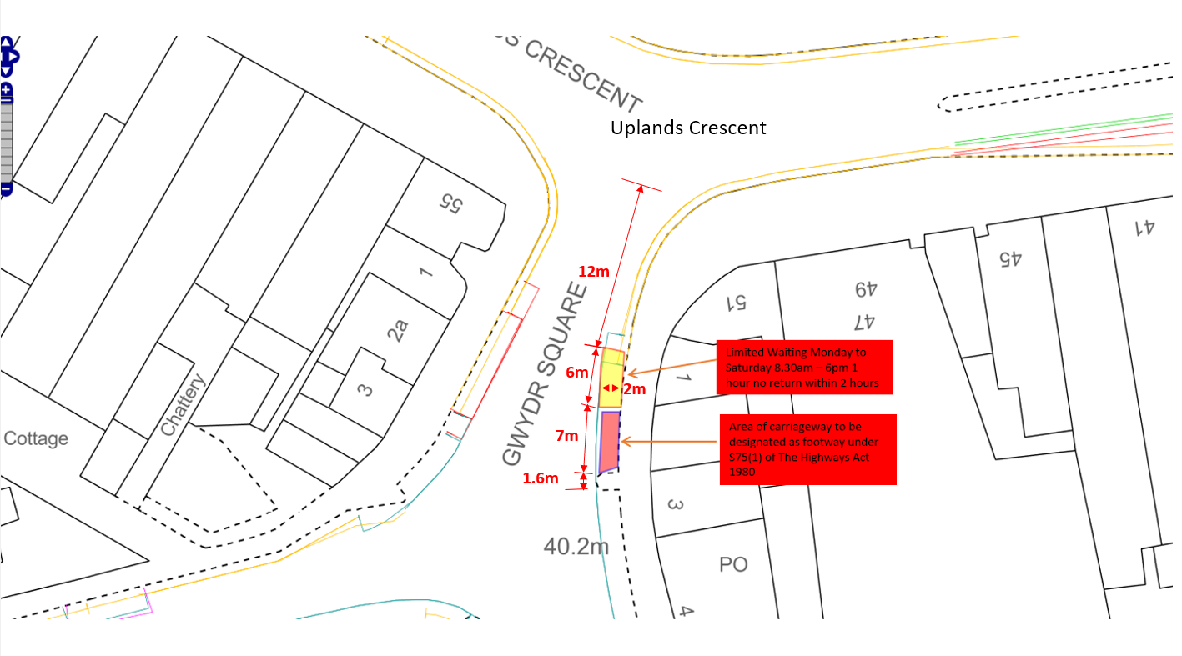
For clairty: Gwydr Square - On its eastern side from a point 18 metres south of its junction with Uplands Crescent southwards for a distance of 7 metres
SCHEDULE 3
Limited Waiting 1 hour no return within 2 hours Mon – Sat 8.30am – 6.00pm
Gwydr Square
On its eastern side from a point 12 metres south of its junction with Uplands Crescent southwards for a distance of 6 metres
SCHEDULE 3
Prohibition of Waiting, No Loading/ Unloading At Any Time
Gwydr Square
On its eastern side from a point 18 metres south of its junction with Uplands Crescent southwards for a distance of 7 metres


7th November 2025
L A Moore
Chief Legal Officer / Prif Swyddog Cyfreithiol

