ENTERING DEATH REFERRALS TO THE CORONER ON THE PORTAL

In order to enter the death referral for your patient on the Portal firstly follow the link provided below:

https://coronersswanseaportal.icasework.com/form?Type=CorornersReferral&Login=False

Any boxes in red are mandatory and must be filled in or the system will not allow you to move to the next page.

You can click on PREVIOUS, which is at the bottom of each page if there is something you need to amend or enter – everything you have entered will still be there.

Please ensure accurate spelling when entering COD and any personal information about the deceased eg name

Screen 1 – Deceased Details

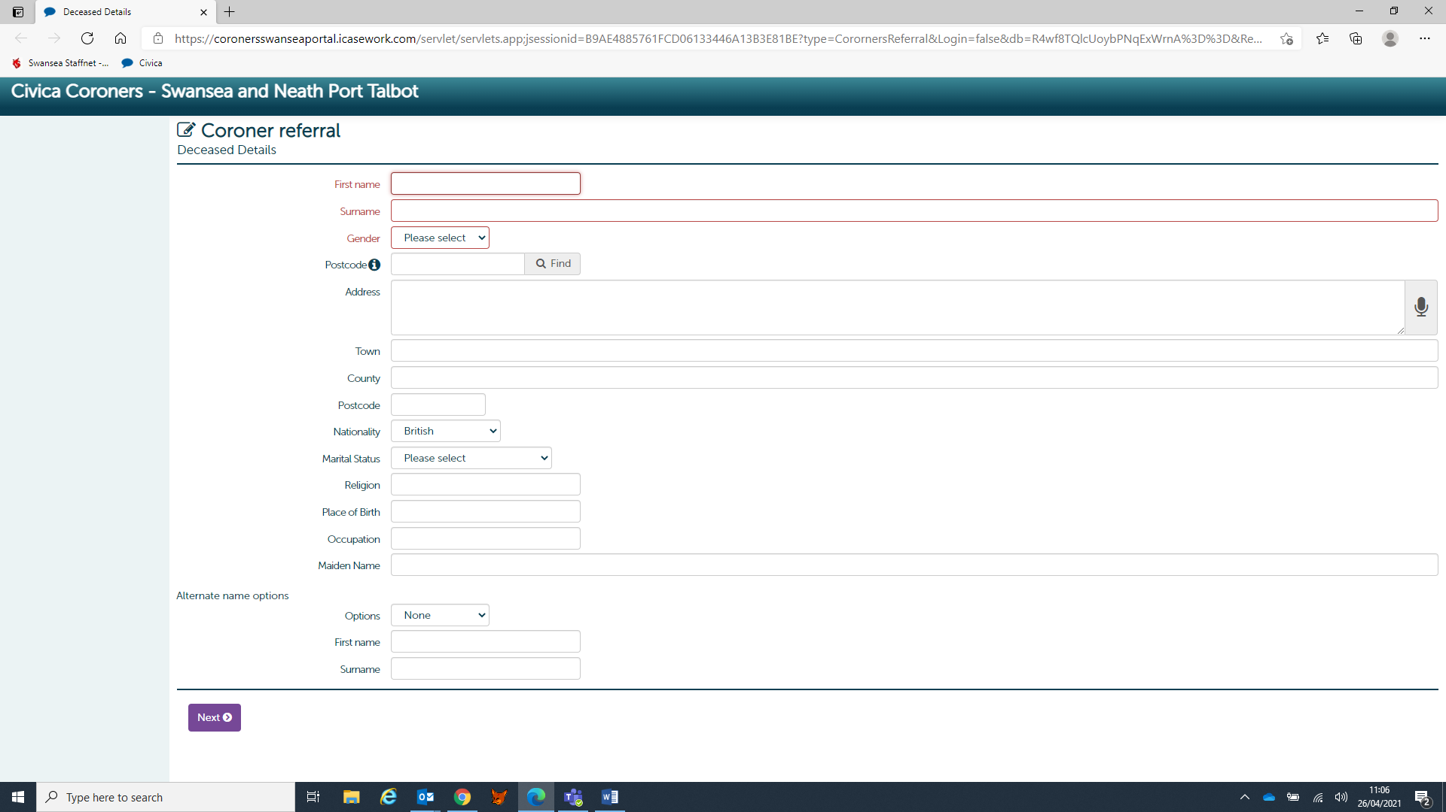

Please fill in the name, sex and address of the deceased. If the postcode is entered in the box below Gender, the system will bring up addresses in that postcode and populate the address box for you. Please delete West Glamorgan from the County box as that always comes up and obviously no longer exists as a County. If you know deceased’s marital status please enter that field. Click NEXT to go to the second screen.

Screen 2 – Referrer Details

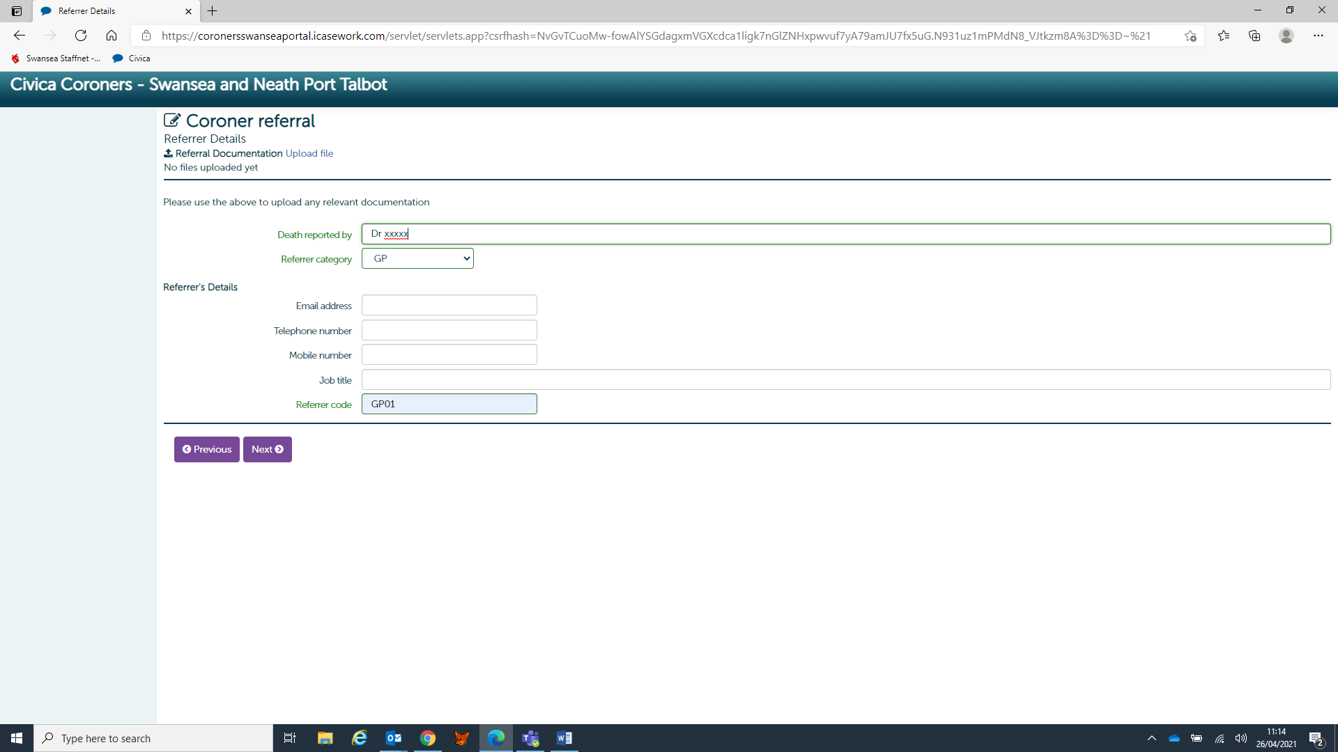

This page is information about who is referring the death. The mandatory fields are the name of the referrer, their category eg GP and the Referrer Code which will always be GP01 for GP’s. Please could you also enter an email address and telephone number for the Coroner’s Officer to use as a means of contacting the Referrer? If you have any supporting documents which need to be forwarded to the Coroner eg Patient Summary, MCCD etc click on Upload File which is at the top of this screen next to Referral Documentation to attach the documents to your referral.

Screen 3 (top half) – Details of Death

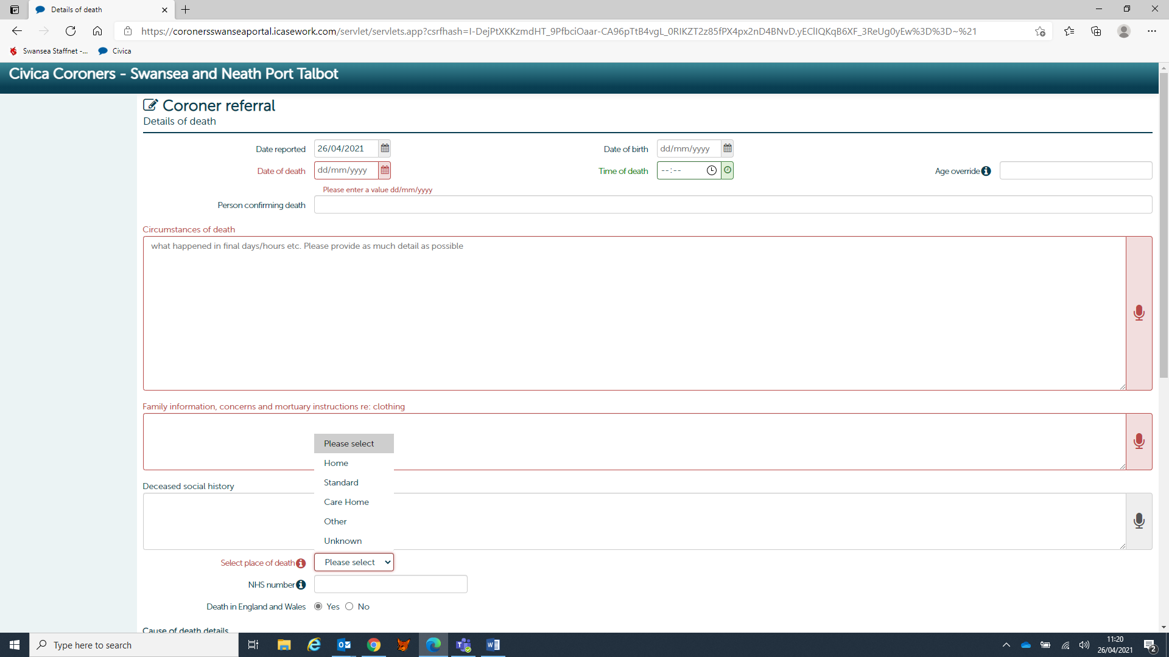

In the top half of this page, the mandatory fields are:-

- Date of death
- Circumstances of death
- Family information, concerns and mortuary instructions
- Place of death

The Date Reported will automatically populate when you fill in the information on the referral. Please fill in the time of death and the date of birth.

The Circumstances of death box requires information about the final days/hours of the deceased in as much detail as possible.

Family information – if any concerns have been raised by the family please enter them here. If you are not aware of any then just enter Not Known – if nothing is entered, as this is a mandatory field the system will not allow you to progress to the final page

Place of death – this is a drop down menu and the correct field will need to be selected. If the deceased died at home, select HOME and nothing further will need to be added about the address. If CARE HOME is selected and that was not the home address entered on Screen 1, the name of the Care Home will need to be entered.

Screen 3 (lower half) – Details of Death

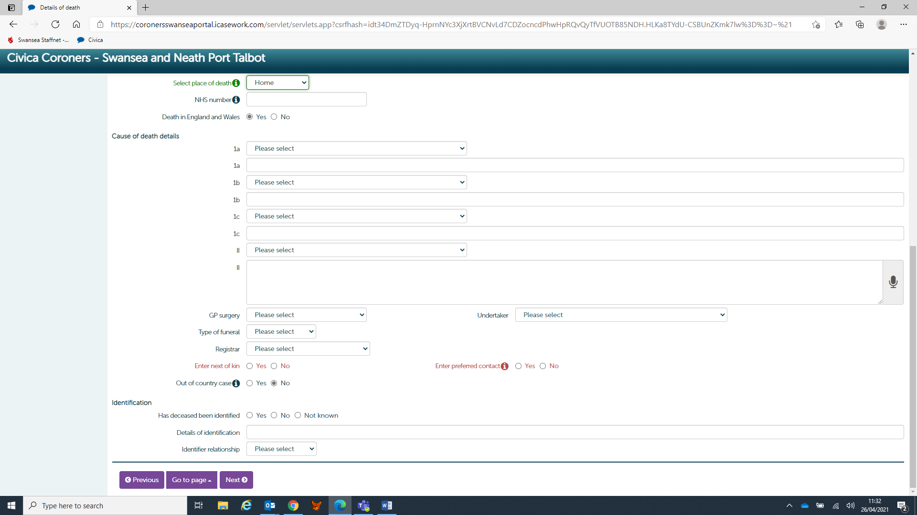

The mandatory fields here are if there is a Next of Kin and if there is a Preferred Contact.

Please fill in the Causes of Death – If you click on the arrow next to Please Select a number of COD’s have already been saved and if the COD required is on that list simply click on it. If the COD you need is not on that list firstly make sure Please Select is still showing (this is at the top of the list of possible COD’s) and then enter the COD’s manually in the blank 1a, 1b, 1c, Part II boxes.

Next click on the GP Surgery arrow and select the correct surgery. Either the Registrar will be Neath or Swansea depending on where the patient died (not where they lived) – the Registrars will be on the drop down menu.

Next of kin – If the deceased has a known NOK select YES, if they do not then select NO.
Enter Preferred Contact – Sometimes the NOK finds it difficult to deal with death of their relative and would prefer someone else to be the Preferred Contact. If this is not the case or you simply do not know, just select NO for Preferred Contact.

Do not worry about completing the Identification information at this stage if you are not sure what to put.

Screen 4 – Medical Referral Details

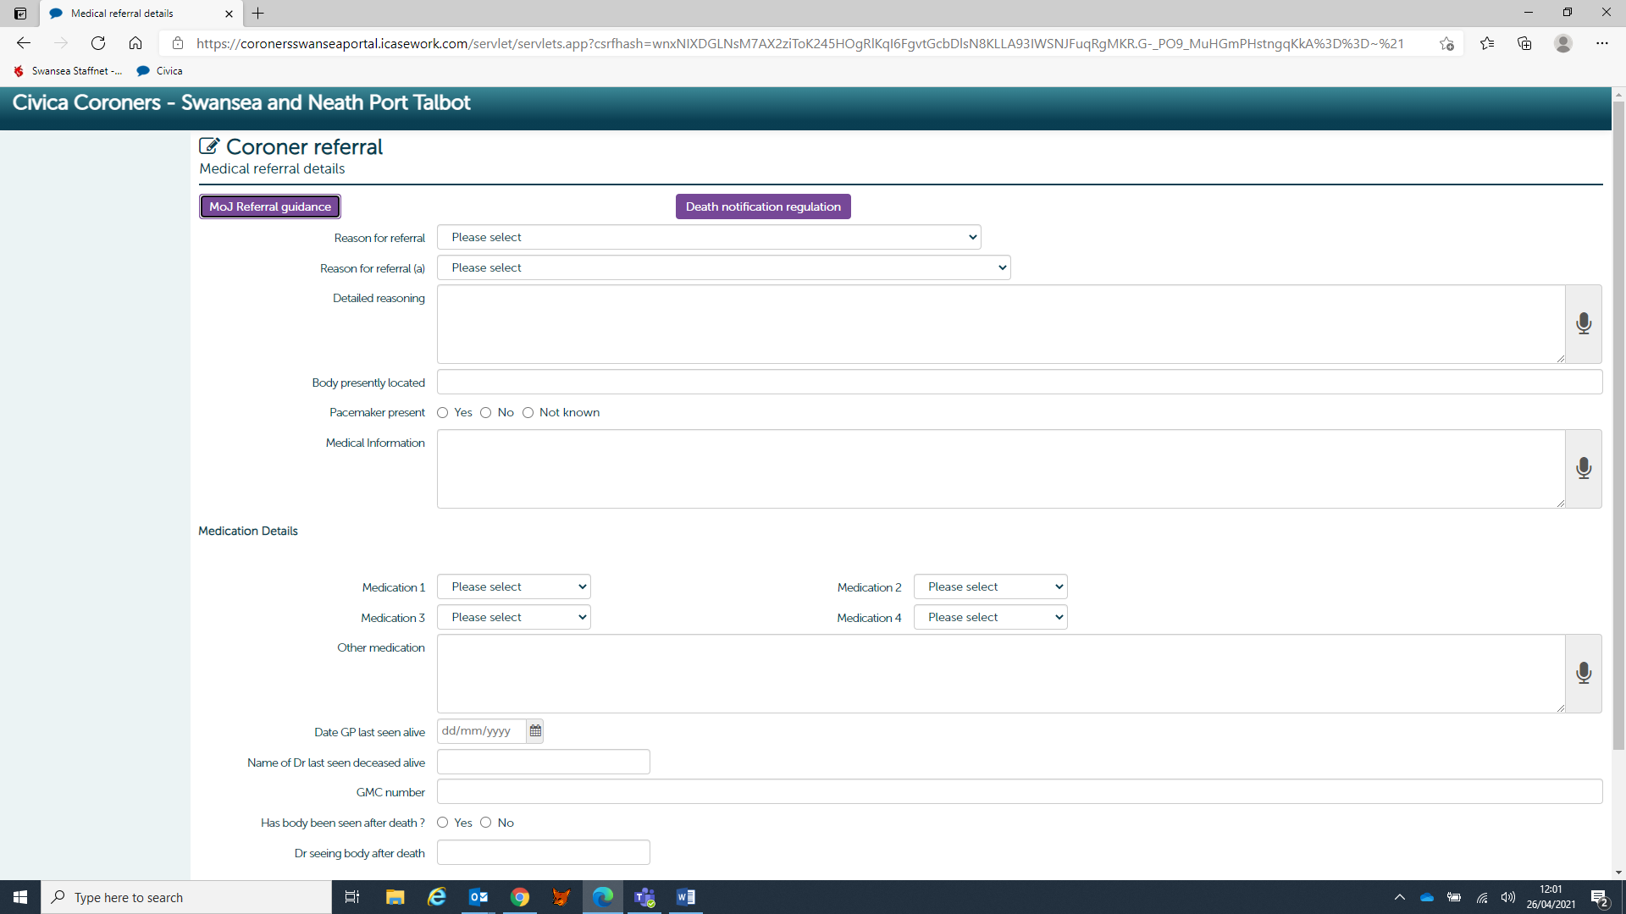

There are no Mandatory Fields on this screen but it is important that the following are completed:-

- Reason for Referral – why the death is being referred to the Coroner eg Patient not seen within the last 28 days
- Pacemaker Present – Yes, No, Not known
- Date Last seen by GP and name of that GP

Screen 5 – Next of Kin Details

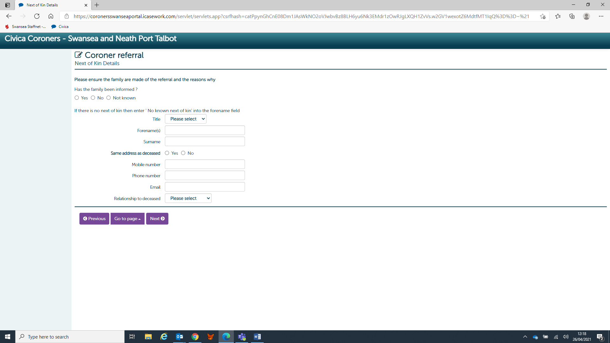

Firstly, please click on either Yes, No or Not known for Has the Family been Informed.

Now enter the name and address (if address is known), Contact Number of the NOK and their relationship to the deceased. - This will be the person the Coroner’s Officer will contact about the death. It might not be the immediate NOK but could be another relative or friend who they would prefer to deal with the death of their loved one.

Click NEXT and the document will be entered on the Coroner’s system.

If you are not sure about how to enter something, as long it is not a mandatory field this can be d

ealt with by the Coroner’s staff.

For any help or support please contact the Coroner’s Admin Team on 01792 636237

