Gower Activity Centres: Creating

Sustainability

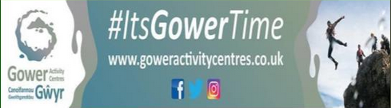

The Gower Activity Centre Feasibility Study aims to develop a plan to maximise the potential of the Gower Activity Centres, namely Ty-Borfa and Ty Rhossili and in particular Ty-Rhossili and to be continue to offer a subsidised service to young people and families.

The activity centres also plan to capitalise on a recent Dark Sky assessment regarding Gower and the Ty Rhossili site; Work with key partners to be able to develop a business model which provides both subsidised and commercial opportunities; Create a legal structure which encourages investment, funding capability and facility improvements and create an internationally recognised dark sky tourism destination, utilising and developing Gower Activities Centres, bringing benefit to local communities and businesses.

The feasibility report will address how to create a sustainable service enabling those in society most in need to be able to continue to access this subsidised service.

Gower Activity Centres provides subsidised, positive life experiences to schools, youth services, pupil referral units and some of the most in need members of our society.

**Project Information:**

|  |  |
| --- | --- |
| Total Project Cost: | £9,925 |
| Total EU/Welsh Government Funding: | £7,940 |

**Mae’r ddogfen hefyd ar gael yn Gymraeg**

**This document is also available in Welsh**