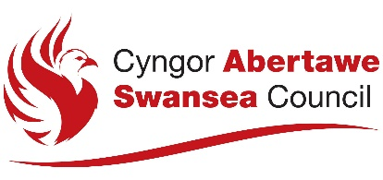

Format for notice to be published

NOTICE OF APPLICATION FOR A REVIEW OF A PREMISES LICENCE

An application has been made under section 197 of the Gambling Act 2005 for a review of the premises licence which is in force in respect of the following premises:

[Give the trading name used at the premises, and the address of the premises (or, if not known, give a description of the premises and their location.]

The following type of premises licence applies to the premises:

A review is being sought on the following grounds:

An application has been made on:

[Insert the date on which the application has been made.]

The licence holder or a responsible authority may make representations in writing about the application as may any of the following persons:
- A person who lives sufficiently close to the premises likely to be affected by the authorised activities.
- A person who has business interests that might be affected by the authorised activities.
- A person who represents someone in any of the above two categories.

Any representations are to be made to the following authority:

The Licensing Division
Housing and Public Protection
Directorate of Place
City and County of Swansea
Civic Centre
Oystermouth Road
Swansea
SA1 3SN

www.swansea.gov.uk

and may be made during the period of 28 consecutive days beginning 7 days after the date on which the applications was made. That period ends on:
[Insert last day on which representations may be made in relation to the application.]

Information about the application is available from the licensing authority, including the arrangements for viewing the details of the application.

It is an offence under section 342 of the Gambling Act 2005 if a person, without reasonable excuse, gives to a licensing authority for a purpose connected with the Act information which is false or misleading.

