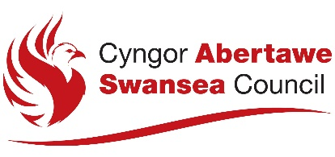

NOTICE OF APPLICATION FOR A REVIEW OF A PREMISES LICENCE

This notice is given in accordance with regulations made under section 197 of the Gambling Act 2005

Notice is hereby given that:

[Give the full name of the applicant(s) as set out in Part 1 of the application for a review of the premises licence]

has made an application under section 197 of the Gambling Act 2005 for a review of the premises licence which is in force as the following premises:

[Give the trading name used at the premises, and the address of the premises (or, if not known, give a description of the premises and their location.]

The applicant is:

A responsible authority
An interested party

[check or tick the appropriate box]

The following type of premises licence has effect in respect of the premises:

[Indicate the type of premises licence which applies to the premises, e.g. bingo premises licence, adult gaming centre premises licence etc.]

The application for a review of the premises licence has been made to the following licensing authority:

The Licensing Division
Housing and Public Protection
Directorate of Place
City and County of Swansea
Civic Centre
Oystermouth Road
Swansea
SA1 3SN

www.swansea.gov.uk

Information about the application is available from the licensing authority, including the arrangements for viewing the details of the application.

The following person connected with the applicant is able to give further information about the application:

[This entry is optional and is to be included if the applicant wishes to provide the name, telephone number and (if available) e-mail address of a person connected with the applicant who is able to answer questions and provide further information about the application.]

The grounds on which a review is being sought are:

Representations about the application may be made in writing to the licensing authority by the licence holder, a responsible authority or an interested party during the period of 28 consecutive days beginning on (which is 7 days after the date on which the application for a review was made to the licensing authority). The last day for making representations is:

Following a review under section 201 of the Gambling Act 2005 a licensing authority may decide to take any of the following kinds of action:

- revoke the licence
- suspend the licence for a specified period not exceeding 3 months
- add, remove or amend a condition attached to the licence

