**FLOW – Fairwood LEADER-funded Outcome-based Work**

**FLOW – Fairwood LEADER-funded**

**Outcome-based Work**

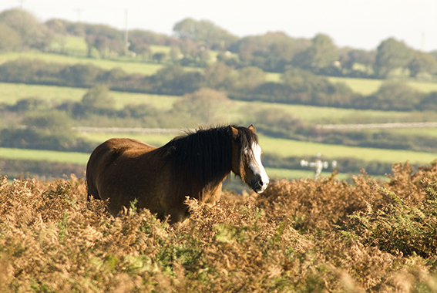This project aims to work closely with graziers, the community and NRW to produce fully tested and costed results based payment proposal specifically for Fairwood Common. Fairwood supports internationally important biodiversity, has been grazed traditionally for centuries and is potentially a valuable component of farm incomes. It is, however, subject to major challenges, where conventional agricultural support schemes have yet to achieve significant results.

The output from the project will be a scheme design which graziers view as flexible, workable and worthwhile and which, in absence of relevant support from forthcoming Sustainable Farming Scheme, could be implemented through management agreements via NRW and inform other such agreements within Swansea and beyond.

Fairwood Common needs active management, principally through grazing, to prevent changes in vegetation that would lead to the reduction of grazing value, biodiversity loss, increased fire risk, loss of recreation/landscape value. Such management has been difficult to achieve due to a range of issues; not least of which are the challenges posed by TB regulations and roadkill. Current payment schemes have not proved to be a sufficient incentive to encourage management due to their restrictive format.

 Results-based schemes/payments could however, offer an attractive alternative with no commitment to any specific management activity and thus allows a high degree of flexibility. Working in collaboration with Gower Commoners’ Association, our aim is to create a sufficiently attractive results-based, fully-costed scheme so graziers feel it is worth forming an association to start negotiations on a management agreement with NRW/Welsh Government.

**Project Information:**

|  |  |
| --- | --- |
| Total Project Cost: | £14,255 |
| Total EU/Welsh Government Funding: | £9,979 |

**Mae’r ddogfen hefyd ar gael yn Gymraeg**

**This document is also available in Welsh**